Module-1 Critical Thinking Assignment
Option-2: Linear Regression Model for Algebraic Equation Prediction

Jibran Gill
Colorado State University Global
CSC580 – Applying Machine Learning and Neural Networks - Capstone
Dr. Bingdong Lee

Table of Contents
Introduction 3
Methodology 3
Menu-Based Interaction System 3
Manual Input Mode 4
Predefined Test Cycle Mode 4
Model Training 5
Prediction and Visualization 5
Results and Observations 6
Perfect Model Accuracy 6
Learned Coefficients Match True Coefficients 6
Predictions Match Actual Values 6
Visualization Confirms Perfect Fit 6
Conclusion 7
References 8
Appendix-A: Program Source Code 9
Appendix-B: Program Outputs 13
Main Menu 13
Manual Values Mode 13
Pre-Defined Test Cycles 14

Option-2: Linear Regression Model for Algebraic Equation Prediction

Introduction
The purpose of this Module 1 Critical Thinking Assignment is to develop a machine learning program that can accurately predict the output of a multivariable algebraic equation using linear regression. Because the equation itself is not directly available to the model, the program generates synthetic training data that strictly follows the mathematical structure defined by the user or selected preset. The machine learning model must then learn this relationship through supervised learning and make predictions based on new inputs.
While working on this assignment, I became curious about whether other machine learning methods could also learn the same algebraic relationship. This led me to briefly explore alternative approaches such as Decision Tree Regression, K-Nearest Neighbors (KNN), and simple Neural Networks. Although linear regression is the most appropriate model for a strictly linear equation, these other methods can approximate such relationships under the right conditions. This exploration helped deepen my understanding of the flexibility and limitations of various regression algorithms.
The final program includes a menu-driven interface, manual and predefined testing modes, equation construction, training diagnostics, model evaluation, and visualization of predicted versus actual values using Matplotlib.

Methodology

Menu-Based Interaction System
The application guides the user with a clear menu:
- Enter manual values
- Use a predefined test cycle
- Quit
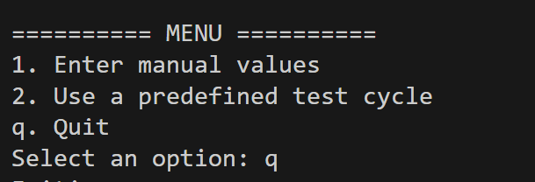
This structure provides flexibility for both user-driven experiments and automated predictable testing.

Manual Input Mode
In this mode, the user enters:
- The number of variables (between 4 and 8)
- Coefficients for each variable
- Test input values
The program prints the full algebraic equation in readable form, e.g. y = 3x1 + 2x2 – 1x3 + 4x4

Predefined Test Cycle Mode
To support reproducibility and consistent testing, several preset configurations are provided. Each includes:
- A fixed number of variables
- A predefined coefficient list
- A matching test input vector
- Synthetic Data Generation
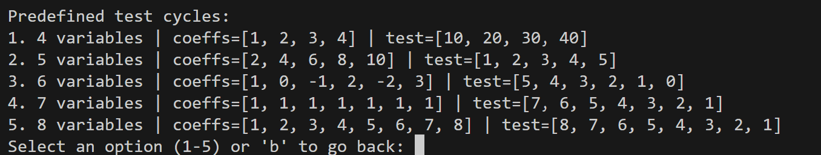
Since the true equation is unknown to the machine learning model, the program generates 500 synthetic training samples. Each sample:
- Randomly selects input values between 0 and 1000
- Computes output using: 𝑦=𝑐1𝑥1+𝑐2𝑥2+⋯+𝑐𝑛𝑥𝑛
This ensures the dataset perfectly follows the user-defined algebraic relationship.

Model Training
The model uses scikit-learn’s LinearRegression(fit_intercept=False), which is appropriate because the algebraic equation contains no constant term. The model is trained using the generated dataset and outputs:
- Number of training samples
- R² score (typically 1.0000 because the data has no noise)
- Learned coefficients
These learned coefficients should match the true coefficients.

Prediction and Visualization
After training, the program does the following:
- Computes the predicted output
- Computes the actual output using the true equation
- Displays both values for comparison
A scatter plot is generated which shows:
- Training predictions vs actual outputs
- An ideal reference line (y = x)
- The user’s test point marked with “X”
- An annotation box displaying learned coefficients and predicted/actual values
This provides visual confirmation that the model correctly learned the equation.

Results and Observations

Perfect Model Accuracy
For all variable counts (4–8), the model achieved R² = 1.0000. This occurs because the relationship is perfectly linear and the training data is noise-free.

Learned Coefficients Match True Coefficients
Example:
True Coefficients: [1, 0, -1, 2, -2, 3]
Model Learned Coeffs: [1.00, 0.00, -1.00, 2.00, -2.00, 3.00]
Very small floating-point rounding artifacts (e.g., 2.22e-16) were observed but are trivial.

Predictions Match Actual Values
Example:
Predicted Value : 4.0000
Actual Value : 4.0000
This confirms perfect reconstruction of the underlying algebraic equation.

Visualization Confirms Perfect Fit
The scatter plot showed:
- All training points lying directly on the diagonal y=x line
- The test point exactly aligned
This verifies that the model learned the equation with complete precision.

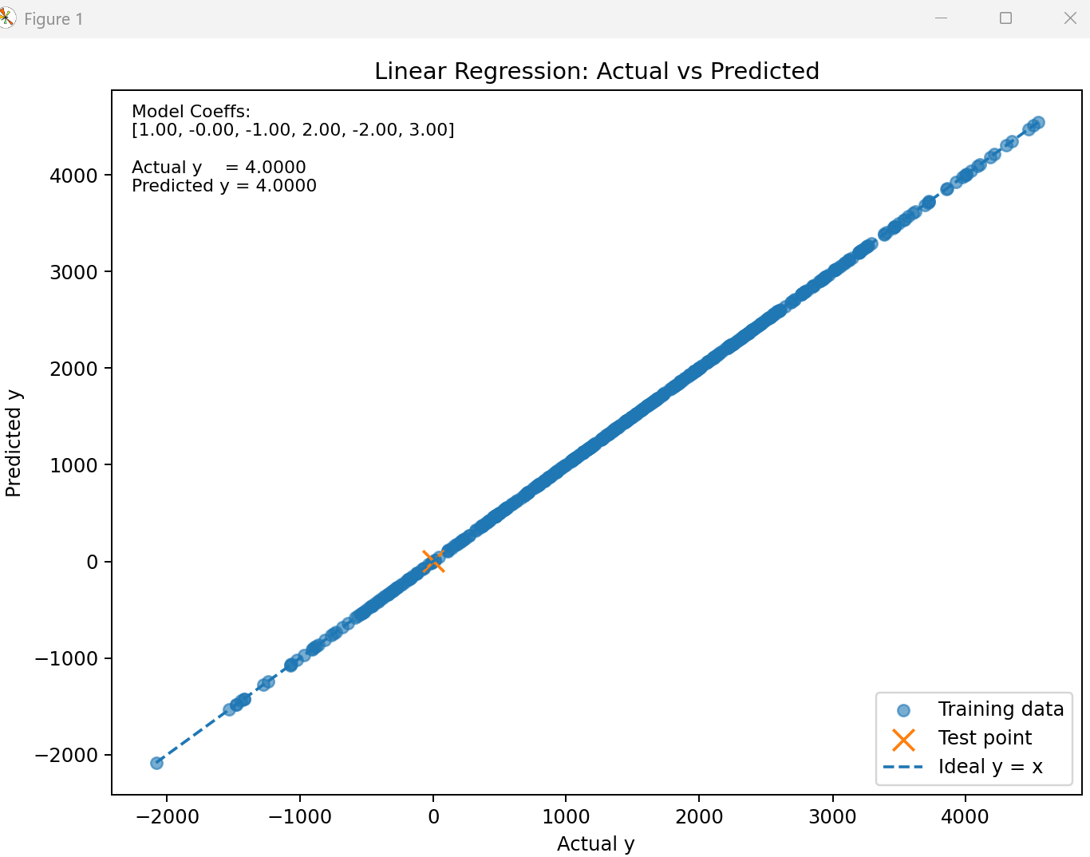

Conclusion
This project demonstrates that linear regression can accurately reconstruct a multivariable algebraic equation based solely on synthetic training data. The model:
- Recovered the exact underlying coefficients
- Achieved perfect predictive accuracy
- Performed consistently across 4–8 variable configurations
- Clearly visualized performance through actual vs predicted scatter plots
Exploring alternative algorithms further reinforced why linear regression is the optimal choice for this task: it is simple, interpretable, computationally efficient, and mathematically aligned with the linear structure of the problem.

References
- Brownlee, J. (2020). K-Nearest Neighbors for Machine Learning. Machine Learning Mastery. https://machinelearningmastery.com/k-nearest-neighbors-for-machine-learning/
- GeeksforGeeks. (2022, February 28). Introduction to Artificial Neural Networks. https://www.geeksforgeeks.org/introduction-to-artificial-neural-networks/
- GeeksforGeeks. (2023, May 22). Decision Tree Regression in Python using scikit-learn. https://www.geeksforgeeks.org/decision-tree-regression-in-python-using-scikit-learn/
- GeeksforGeeks. (2023). Linear Regression in Python using scikit-learn. https://www.geeksforgeeks.org/linear-regression-python-implementation/
- scikit-learn developers. (n.d.). Linear Regression. https://scikit-learn.org/stable/modules/generated/sklearn.linear_model.LinearRegression.html

Appendix-A: Program Source Code
from random import randint
from sklearn.linear_model import LinearRegression
import matplotlib.pyplot as plt

TRAIN_SET_LIMIT = 1000
TRAIN_SET_COUNT = 500

def run_cycle(num_vars, coefficients, test_input=None):
equation_terms = []
for i, c in enumerate(coefficients):
if c % 1 == 0:
c = int(c)
equation_terms.append(f"{c}x{i+1}")
equation_str = " + ".join(equation_terms)

print("\n==========================================")
print("The algebraic equation being modeled is:")
print(f"y = {equation_str}")
print("==========================================\n")

train_input = []
train_output = []
for _ in range(TRAIN_SET_COUNT):
inputs = [randint(0, TRAIN_SET_LIMIT) for _ in range(num_vars)]
output = sum(c * x for c, x in zip(coefficients, inputs))
train_input.append(inputs)
train_output.append(output)

model = LinearRegression(fit_intercept=False)
model.fit(train_input, train_output)

y_train_pred = model.predict(train_input)
r2 = model.score(train_input, train_output)

print("Training info:")
print(f" Samples : {TRAIN_SET_COUNT}")
print(f" Variables : {num_vars}")
print(f" R^2 score : {r2:.4f}\n")

if test_input is None:
print("Enter test values to evaluate the model:")
test_input = []
for i in range(num_vars):
val = float(input(f"Value for x{i+1}: "))
test_input.append(val)
else:
print("Using predefined test values:")
for i, v in enumerate(test_input, start=1):
print(f" x{i} = {v}")
print()

predicted = model.predict([test_input])[0]
actual = sum(c * x for c, x in zip(coefficients, test_input))

print("\n=========== RESULT ===========")
print(f"Predicted Value : {predicted:.4f}")
print(f"Actual Value : {actual:.4f}")
print("\nModel Learned Coefficients:")
print(model.coef_)
print("================================\n")

train_actual = train_output
train_pred = list(y_train_pred)
min_y = min(train_actual + [actual, predicted])
max_y = max(train_actual + [actual, predicted])

plt.figure(figsize=(8, 6))
plt.scatter(train_actual, train_pred, alpha=0.6, label="Training data")
plt.scatter([actual], [predicted], marker="x", s=120, label="Test point")
plt.plot([min_y, max_y], [min_y, max_y], linestyle="--", label="Ideal y = x")
plt.xlabel("Actual y")
plt.ylabel("Predicted y")
plt.title("Linear Regression: Actual vs Predicted")

coeff_str = ", ".join(f"{c:.2f}" for c in model.coef_)
text_block = (
"Model Coeffs:\n[" + coeff_str + "]\n\n"
+ f"Actual y = {actual:.4f}\n"
+ f"Predicted y = {predicted:.4f}"
)

ax = plt.gca()
ax.text(
0.02,
0.98,
text_block,
transform=ax.transAxes,
fontsize=9,
verticalalignment="top",
bbox=dict(facecolor="white", alpha=0.7, edgecolor="none"),
)

plt.legend()
plt.tight_layout()
plt.show()

def manual_mode():
num_vars = int(input("Enter number of variables (4-8): "))
if num_vars < 4 or num_vars > 8:
raise ValueError("Invalid number of variables. Must be between 4 and 8.")

coefficients = []
print("\nEnter the coefficient for each variable:")
for i in range(num_vars):
coef = float(input(f"Coefficient for x{i+1}: "))
coefficients.append(coef)

run_cycle(num_vars, coefficients)

def predefined_mode():
presets = {
"1": {
"label": "4 variables",
"num_vars": 4,
"coeffs": [1, 2, 3, 4],
"test": [10, 20, 30, 40],
},
"2": {
"label": "5 variables",
"num_vars": 5,
"coeffs": [2, 4, 6, 8, 10],
"test": [1, 2, 3, 4, 5],
},
"3": {
"label": "6 variables",
"num_vars": 6,
"coeffs": [1, 0, -1, 2, -2, 3],
"test": [5, 4, 3, 2, 1, 0],
},
"4": {
"label": "7 variables",
"num_vars": 7,
"coeffs": [1, 1, 1, 1, 1, 1, 1],
"test": [7, 6, 5, 4, 3, 2, 1],
},
"5": {
"label": "8 variables",
"num_vars": 8,
"coeffs": [1, 2, 3, 4, 5, 6, 7, 8],
"test": [8, 7, 6, 5, 4, 3, 2, 1],
},
}

print("\nPredefined test cycles:")
for key, cfg in presets.items():
print(f"{key}. {cfg['label']} | coeffs={cfg['coeffs']} | test={cfg['test']}")

choice = input("Select an option (1-5) or 'b' to go back: ").strip()
if choice.lower() == "b":
return
if choice not in presets:
print("Invalid choice.\n")
return

cfg = presets[choice]
print(f"\nSelected: {cfg['label']}")
print(f"Coefficients: {cfg['coeffs']}")
print(f"Test values: {cfg['test']}\n")

run_cycle(cfg["num_vars"], cfg["coeffs"], cfg["test"])

def main():
while True:
print("========== MENU ==========")
print("1. Enter manual values")
print("2. Use a predefined test cycle")
print("q. Quit")
choice = input("Select an option: ").strip().lower()

if choice == "1":
manual_mode()
elif choice == "2":
predefined_mode()
elif choice == "q":
print("Exiting.")
break
else:
print("Invalid choice.\n")
if __name__ == "__main__":
main()

Appendix-B: Program Outputs

Main Menu
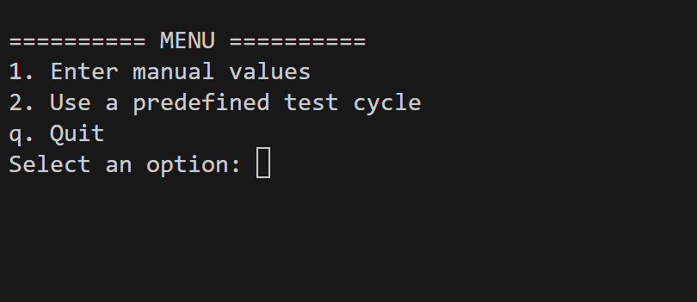

Manual Values Mode
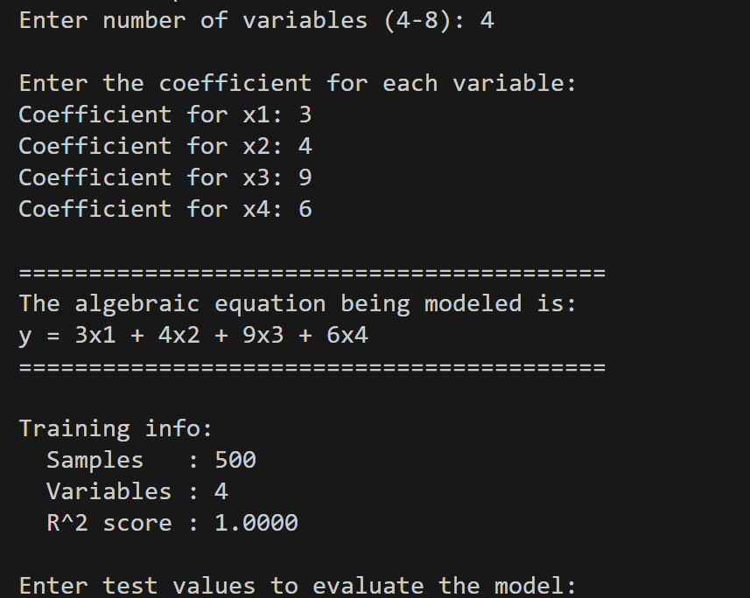
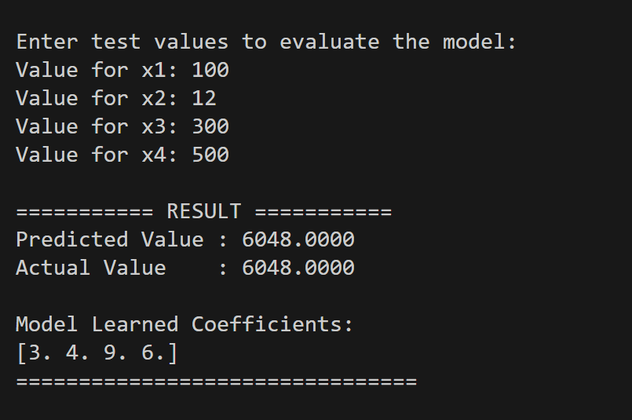
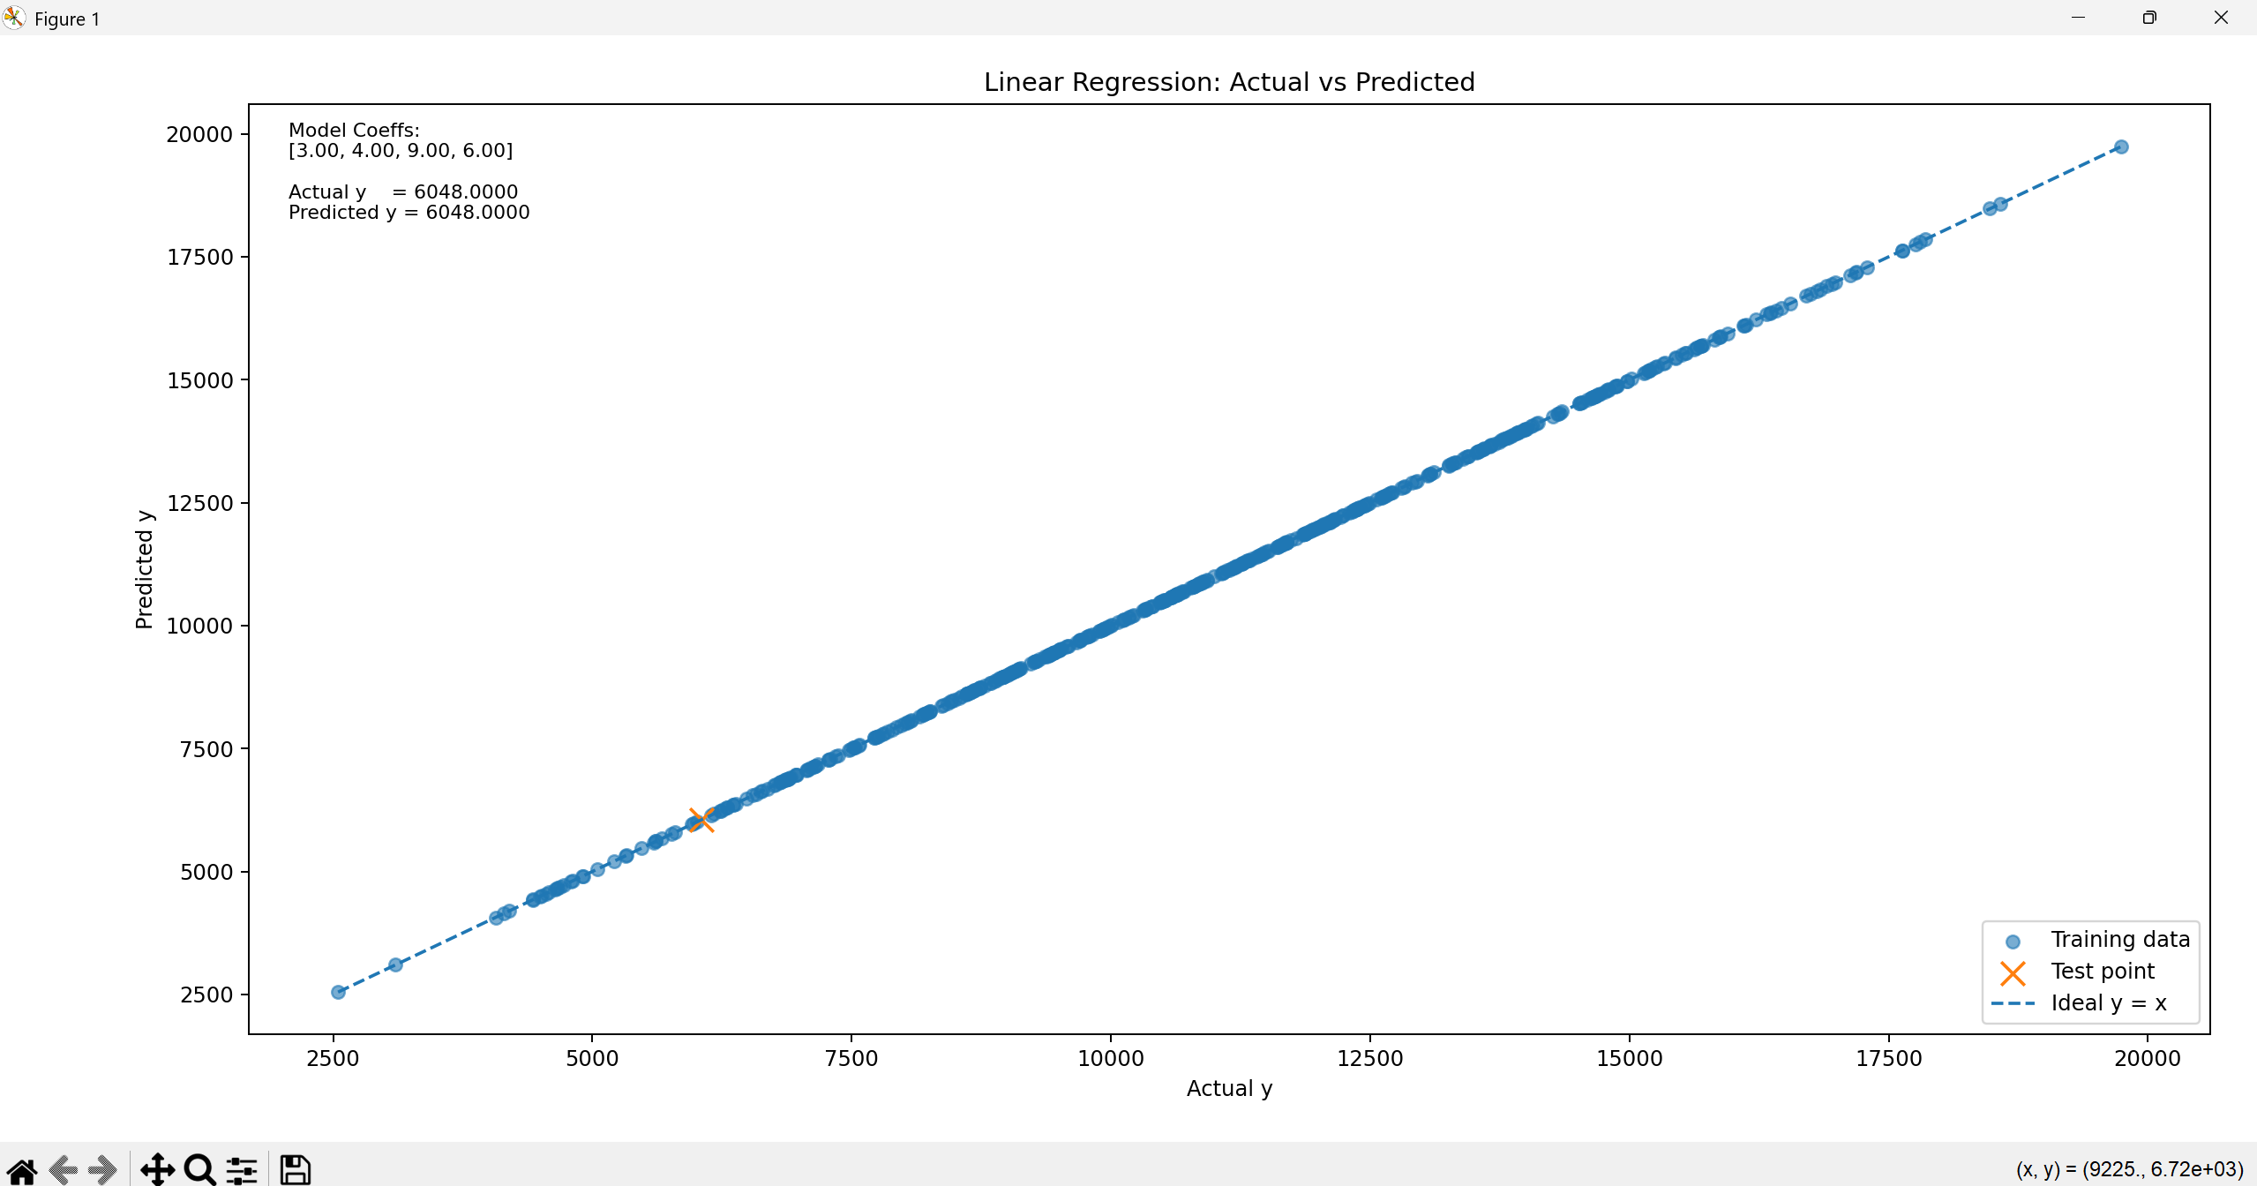

Pre-Defined Test Cycles
